OLADIMEJI ALADEROKUN

219047012

SSG 831

ASSIGNMENT 2

1.

student = [15,25,55,115,144];

semilogy(student, 'ms','MarkerSize', 10, 'LineWidth',4);

title('Student enrollment in 6.094 growth');

xlabel('Years');

ylabel('Students');

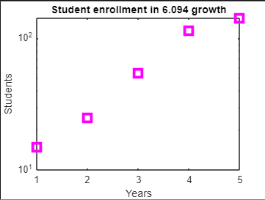

2.

3.

bar(rand(1,5),'red');

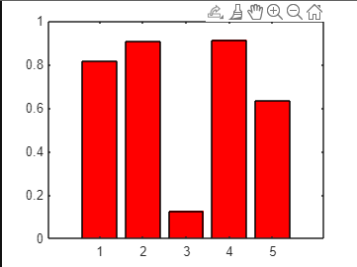

4.

z0=rand(5)

z0 =  
  
 0.8147 0.0975 0.1576 0.1419 0.6557  
 0.9058 0.2785 0.9706 0.4218 0.0357  
 0.1270 0.5469 0.9572 0.9157 0.8491  
 0.9134 0.9575 0.4854 0.7922 0.9340  
 0.6324 0.9649 0.8003 0.9595 0.6787

[x0,y0]=meshgrid(1:5, 1:5)

x0 =  
  
 1 2 3 4 5  
 1 2 3 4 5  
 1 2 3 4 5  
 1 2 3 4 5  
 1 2 3 4 5  
  
  
y0 =  
  
 1 1 1 1 1  
 2 2 2 2 2  
 3 3 3 3 3  
 4 4 4 4 4  
 5 5 5 5 5

%interpolating intermediate value for a smooth surface

[x1,y1]=meshgrid(1:0.1:5, 1:0.1:5)

y1 =

%make z1 by interpolating x0, y0 and z0 using cubic

z1=interp2(x0,y0,z0,x1,y1,'cubic')

%plot a surface plot of z1

surf(x1,y1,z1)

colormap(hsv)

shading interp

hold on;

contour(x1,y1,z1)

colorbar

caxis([0,1])

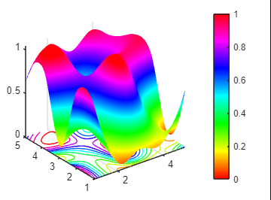

5.

function ind=ssss(x, desiredVal)

x=abs(x(:)-desiredVal);

m=min(x);

ind=find(x==m)';

end

6.

function loopTest(N)

for n = 1:N

if mod(n, 2) == 0 && mod(n, 3) == 0

disp([num2str(n) ' is divisible by 2 and 3']);

elseif mod(n, 2) == 0

disp([num2str(n) ' is divisible by 2']);

elseif mod(n, 3) == 0

disp([num2str(n) ' is divisible by 3']);

else

disp([num2str(n) ' is NOT divisible by 2 or 3']);

end

end

end